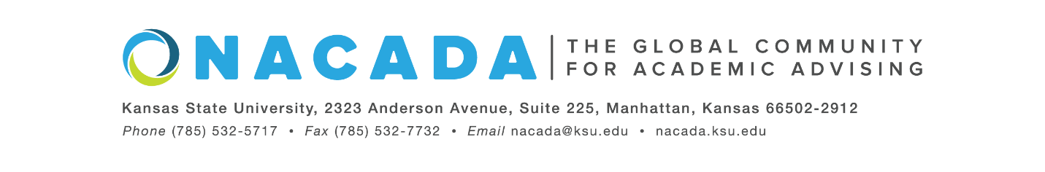
NACADA: The Global Community for Academic Advising
[INSERT DATE]
For Immediate Release
[For more information about the Global Awards Program for Academic Advising, visit https://www.nacada.ksu.edu/Programs/Awards/Global-Awards.aspx]

Or Contact: Lizbeth Alcantara, NACADA: The Global Community for Academic Advising
nawards@ksu.edu
[INSERT NAME] of [INSERT INSTITUTION], is a 2022 Outstanding Advising Award Winner in the Academic Advising Faculty category from NACADA: The Global Community for Academic Advising as part of the 2022 Global Awards Program for Academic Advising.
This category includes faculty with over three years of experience in their field and whose primary responsibility is teaching but a portion of their time is spent providing academic advising services to students. This award is presented to individuals who have demonstrated qualities associated with outstanding academic advising of students in an international competition. In the judgment of the selection committee, this faculty member has consistent evidence of having a sustained institutional impact on students. [INSERT NAME} exemplifies the NACADA Core Values of professional practice including proactively creating advising interactions with students, utilizing campus networks and setting the highest standards for their advising practice while actively teaching.
Since 1983, NACADA has honored individuals and institutions making significant contributions to the improvement of academic advising. The mission of NACADA is to promote quality academic advising and professional development of its membership to enhance the educational development of students. NACADA’s membership has grown to over 14,000 faculty, professional advisors, administrators, counselors, and others in academic and student affairs staff concerned with the intellectual, personal, and vocational needs of students. The organization acts as the representative and advocate of academic advising, and those providing that service, to higher education.
[INSERT NAME] will be honored and presented with this award in Portland, Oregon during the NACADA Annual Conference in fall of 2022.
----end----

